Check List for WFH

|  |  |  |
| --- | --- | --- |
| Jira | <https://jira.na.nissan.biz/> |  |
| Confluence | <https://confluence.na.nissan.biz/> |  |
| DIH Prod | <http://10.78.11.31:18080/dih-console/login.jsp> |  |
| DIH Non Prod | <http://10.78.11.32:18080/dih-console/login.jsp> |  |
| Oozie Prod | <http://usnencpl075.nmcorp.nissan.biz:11000/oozie/> |  |
| Oozie Stage | <http://usnencpl077.nmcorp.nissan.biz:11000/oozie/> |  |
| Ambari Prod | <http://usnencpl075.nmcorp.nissan.biz:8080/#/login> |  |
| Tableau | <https://tableau.na.nissan.biz/#/site/TCS/datasources> |  |
| Service Now | <https://nnanissan.service-now.com/> |  |
| EQUIP Prod Application | <https://datamgtanalytics.na.nissan.biz/> |  |
| Zoom Meeting | <https://nissan-usa.zoom.us/j/8647358496> | IPS Daily standup |
| (master deployment log | <https://confluence.na.nissan.biz/pages/viewpage.action?spaceKey=TCSFQI&title=EQUIP+Master+Deployment+Log>) |  |
| Zeppelin Prod | <http://usnencpl075.nmcorp.nissan.biz:9995/> | To check daily base table loads in Bigdata Environment. |

SQL Developer:

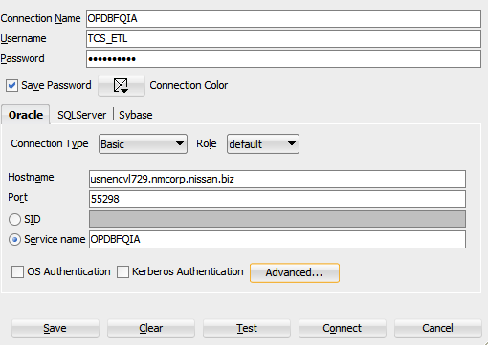

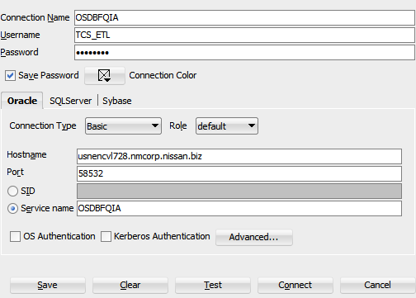

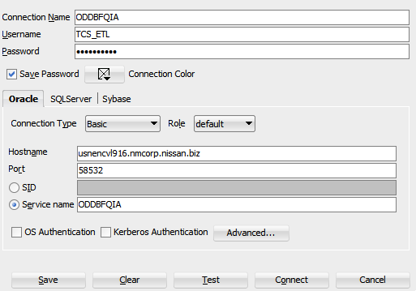

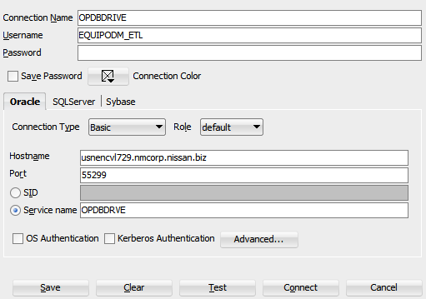

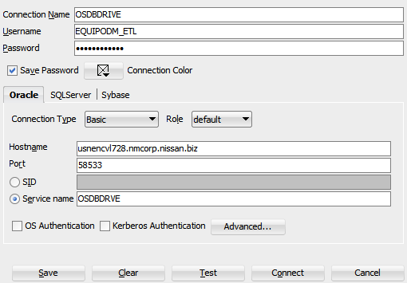

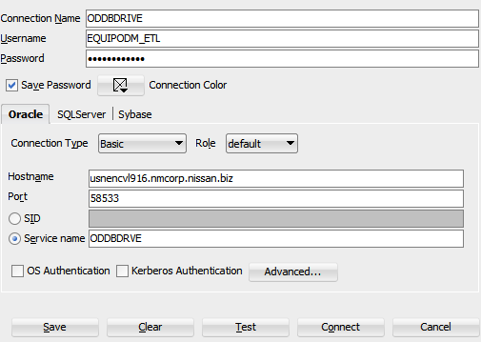

Informatica Configurations :

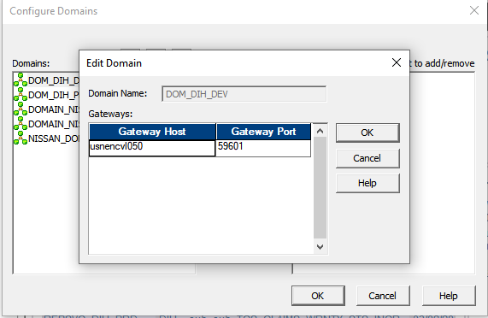

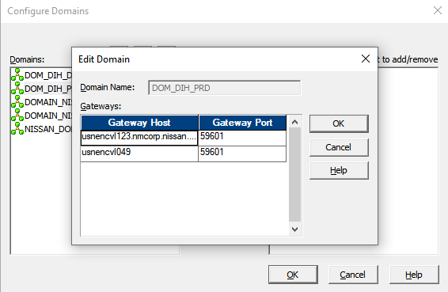

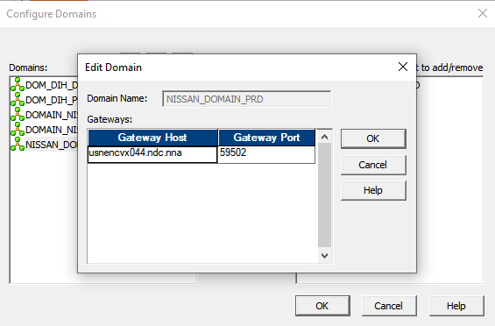

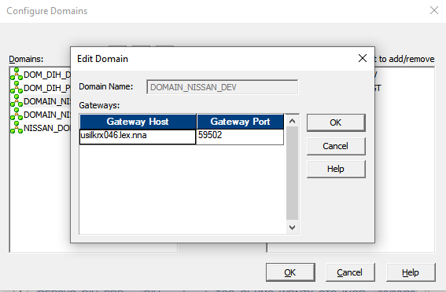

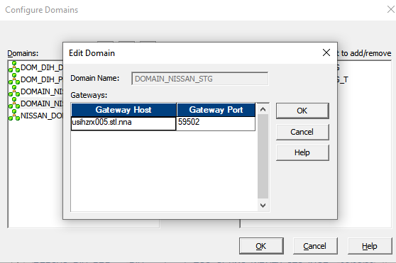

UNIX IPs: – port 22

Informatica Prod-10.78.11.21

Dev-10.78.39.67

Stage-10.78.39.100

Hive Dev-10.79.32.133

Prod-10.79.32.129

Stage-10.79.32.131